

2022

IOMP Project Report on

AI-POWERED NUTRITION ANALYZER FOR FITNESS ENTHUSIAST USING IBWATSON



**SUBMITTED BY**

**NAMBURI AARTHI 19UK1A05G4**

**NAGANABOINA VENNELA 19UK1A05L8 VEERAGANDAM NARMADA 19UK1A05K9**

**ALPULA SAI CHARAN 19UK1A05K4**



**DEPARTMENT OF COMPUTER SCIENCE AND ENGINEERING**

**VAAGDEVI ENGINEERING COLLEGE**

(Affiliated to JNTUH, Hyderabad)

Bollikunta, Warangal – 506005

**2019– 2023**

 | [Company address]

**CONTENTS**

**CHAPTERS PAGE NO’S**

1. **INTRODUCTION 02**
   1. Overview
   2. Purpose
2. **LITERATURE SURVEY 03**
   1. Existing Problem
   2. Proposed Solution
3. **THEORETICAL ANALYSIS 04**
   1. Block Diagram
   2. Hardware and Software Design
4. **EXPERIMENTAL INVESTIGATIONS 05**
5. **FLOWCHART 06-07**
6. **RESULT 08-10**
7. **ADVANTAGES AND DISADVANTAGES 11**
8. **APPLICATIONS 12**
9. **CONCLUSION AND FUTURESCOPE 13**
10. **10. BIBILOGRAPHY 14**

**CHAPTER 1**

**INTRODUCTION**

 The term “artificial intelligence” was first proposed in 1955 by the American computer scientist John McCarthy (1927–2011) in the proposal of a research project, which was carried out the following year at Dartmouth College in Hanover, New Hampshire. Artificial intelligence (AI) as a branch of computer science, the purpose of which is to imitate thought processes, learning abilities and knowledge management, finds more and more applications in experimental and clinical medicine. In recent decades, there has been an expansion of AI applications in medicine and biomedical sciences. The possibilities of artificial intelligence in the field of medical diagnostics, risk prediction and support of therapeutic techniques are growing rapidly. Thanks to the use of AI in ophthalmological, radiological and cardiac diagnostics, measurable clinical benefits have been obtained. AI was used in research on new pharmaceuticals . The development of AI also provides new opportunities for research on nutrients and medical sensing technology.

* 1. **OVERVIEW**

Food is essential for human life and has been the concern of many healthcare conventions. Nowadays new dietary assessment and nutrition analysis tools enable more opportunities to help people understand their daily eating habits, exploring nutrition patterns and maintain a healthy diet. Nutritional analysis is the process of determining the nutritional content of food. It is a vital part of analytical chemistry that provides information about the chemical composition, processing, quality control and contamination of food.

**1.2 PURPOSE**

The main aim of the project is to building a model which is used for classifying the fruit depends on the different characteristics like colour, shape, texture etc. Here the user can capture the images of different fruits and then the image will be sent the trained model. The model analyses the image and detect the nutrition based on the fruits like (Sugar, Fibre, Protein, Calories, etc.).

**CHAPTER 2**

**LITERATURE SURVEY**

**2.1 EXISTING PROBLEM**

**To complete this project, you should have the following software’s and packages**

**Anaconda Navigator:**

Anaconda Navigator is a free and open-source distribution of the Python and R programming languages for data science and machine learning related applications. It can be installed on Windows, Linux, and macOS.Conda is an open-source, cross-platform,  package management system. Anaconda comes with so very nice tools like JupyterLab, Jupyter Notebook, QtConsole, Spyder, Glueviz, Orange, Rstudio, Visual Studio Code. For this project, we will be using Jupiter notebook and spyder.

**2.2 PURPOSED SOLUTION**

The method or solution is  Jupiter notebook and spyder we used to complete this project. and you will use this jupiter notebook for you recommended.

**To build Machine learning models you must require the following packages**

**Sklearn:** Scikit-learn is a library in Python that provides many unsupervised and supervised learning algorithms.

**NumPy:** NumPy is a Python package that stands for 'Numerical Python'. It is the core library for scientific computing, which contains a powerful n-dimensional array object

**Pandas:**pandas is a fast, powerful, flexible, and easy to use open source data analysis and manipulation tool,built on top of the Python programming language.

**Matplotlib:**  It provides an object-oriented API for embedding plots into applications using general-purpose GUI toolkits

**CHAPTER 3**

**THEORETICAL ANALYSIS**

**3.1 BLOCK DIAGRAM**

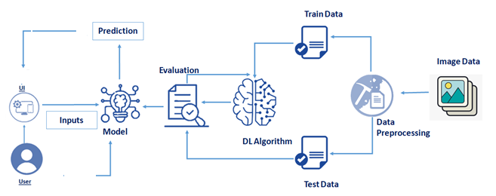

Fig3.1 Ai-Powered Nutrition Analyzer for Fitness Enthusiast Using IBM Watson.

**3.2 HARDWARE / SOFTWARE DESIGNING**

The hardware required for the development of this project is:

      Processor : Intel CoreTM i5-9300H

      Processor speed : 2.4GHz

      RAM Size : 8 GB DDR

      System Type : X64-based processor

**SOFTWARE DESIGNING**:

The software required for the development of this project is:

      Desktop GUI       :  Anaconda Navigator

      Operating system   : Windows 10

      Front end        : HTML, CSS

      Programming   : PYTHON

      Cloud Computing Service  : IBM Cloud Services

**CHAPTER 4**

**EXPERIMENTAL INVESTIGATION**

**IMPORTING AND READING THE DATASET**

**Importing the Libraries**

First step is usually importing the libraries that will be needed in the program.

**Pandas:** It is a python library mainly used for data manipulation.

**NumPy:** This python library is used for numerical analysis.

**Matplotlib and Seaborn:** Both are the data visualization library used for plotting graph which will help us for understanding the data.

**csr_matrix() :**A dense matrix stored in a NumPy array can be converted into a sparse matrix using the CSR representation by calling the csr_matrix() function.

**Train_test_split:** used for splitting data arrays into training data and for testing data.

**Pickle:** to serialize your machine learning algorithms and save the serialized format to a file.

**Reading the Dataset**

For this project, we make use of three different datasets (test_set,train_set). We will be selecting the important features from these datasets that will help us in recommending the best results.

The next step is to read the dataset into a data structure that’s compatible with pandas.  
 Let’s load a .csv data file into pandas. There is a function for it, called **read_csv().**We will need to locate the directory of the CSV file at first (it’s more efficient to keep the dataset in the same directory as your program).If the dataset in same directory of your program, you can directly read it, without any path. After the next Steps we made following bellow:

1.Data visualization

2.Collabrative and filtering

3.Creating the Model

4.Test and save the model

5.Buil Python Code

6.Build HTML Code

7.Run the Application

We are the following above sections we did and investigate it.

**CHAPTER 5**

**FLOWCHART**

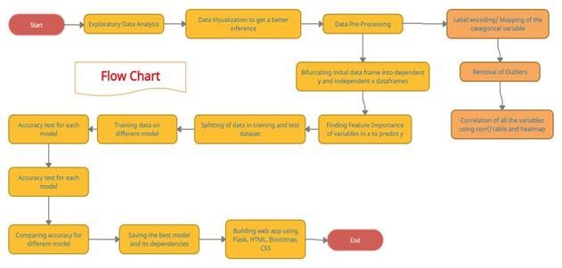

Fig 5.1 Flowchart of the project

**Project Flow:**

* The user interacts with the UI (User Interface) and give the image as input.
* Then the input image is then pass to our flask application,
* And finally with the help of the model which we build we will classify the result and showcase it on the UI.

To accomplish this, we have to complete all the activities and tasks listed below

* Data Collection.
  + Collect the dataset or Create the dataset
* Data Preprocessing.
* Import the ImageDataGenerator library
* Configure ImageDataGenerator class
* ApplyImageDataGenerator functionality to Trainset and Testset
* Model Building
  + Import the model building Libraries
  + Initializing the model
  + Adding Input Layer
  + Adding Hidden Layer
  + Adding Output Layer
  + Configure the Learning Process
  + Training and testing the model
  + Save the Model
* Application Building
  + Create an HTML file
  + Build Python Code

**CHAPTER 6**

**RESULT**

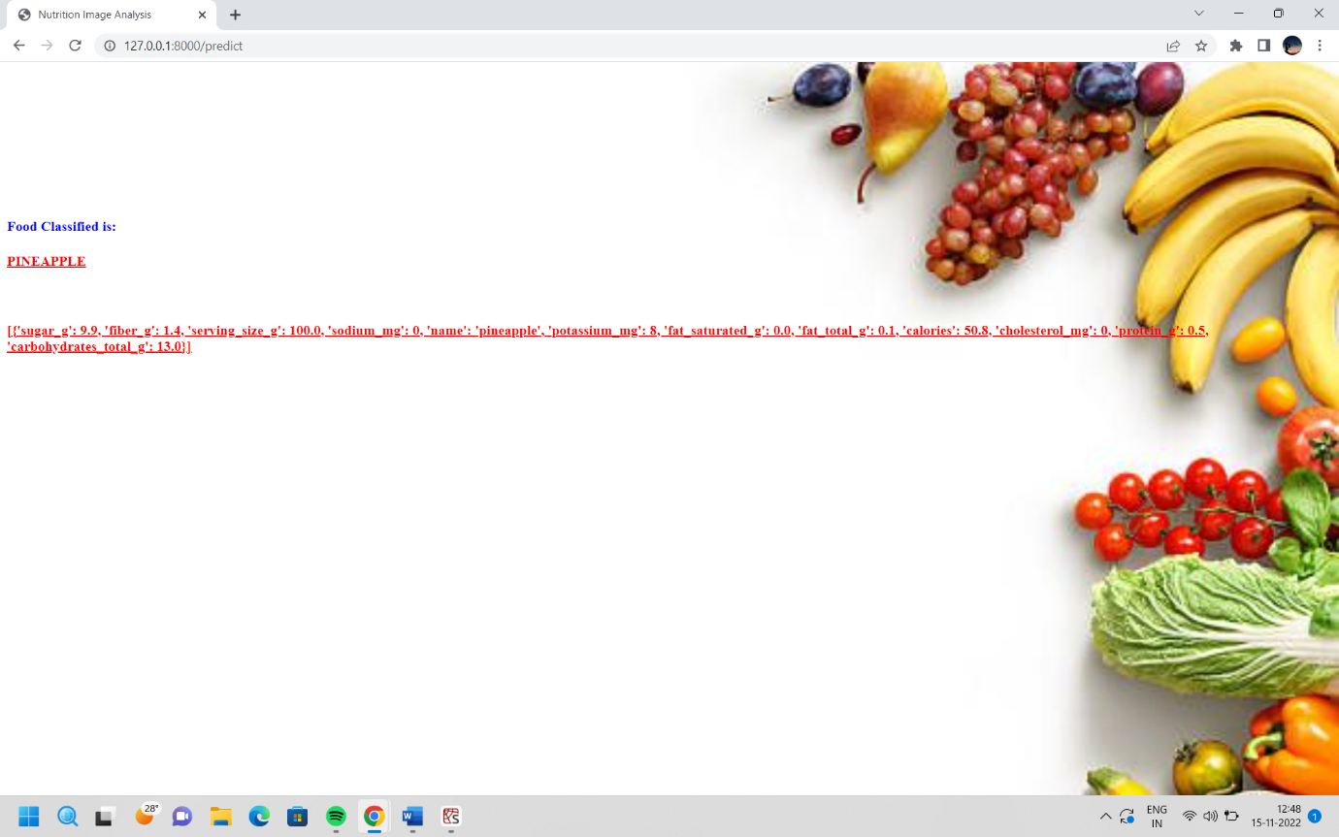

Fig 6.1 Output Page Ai-pow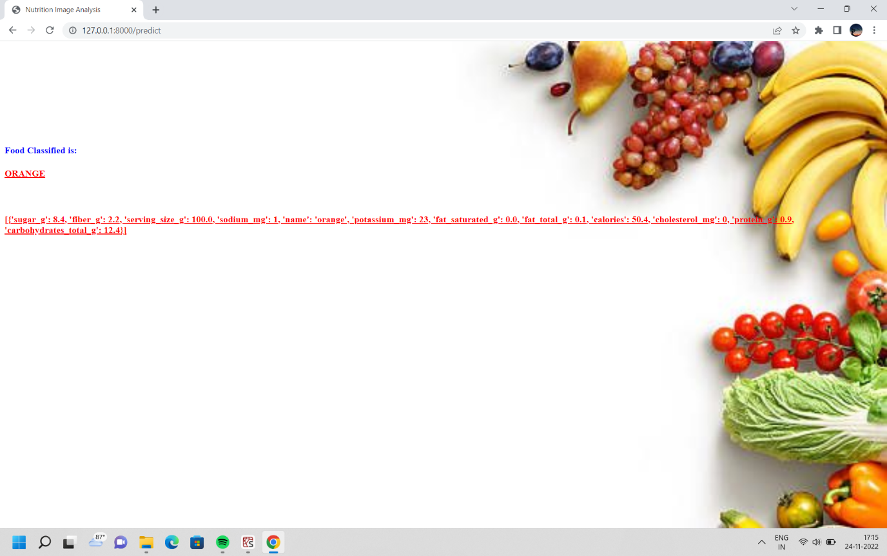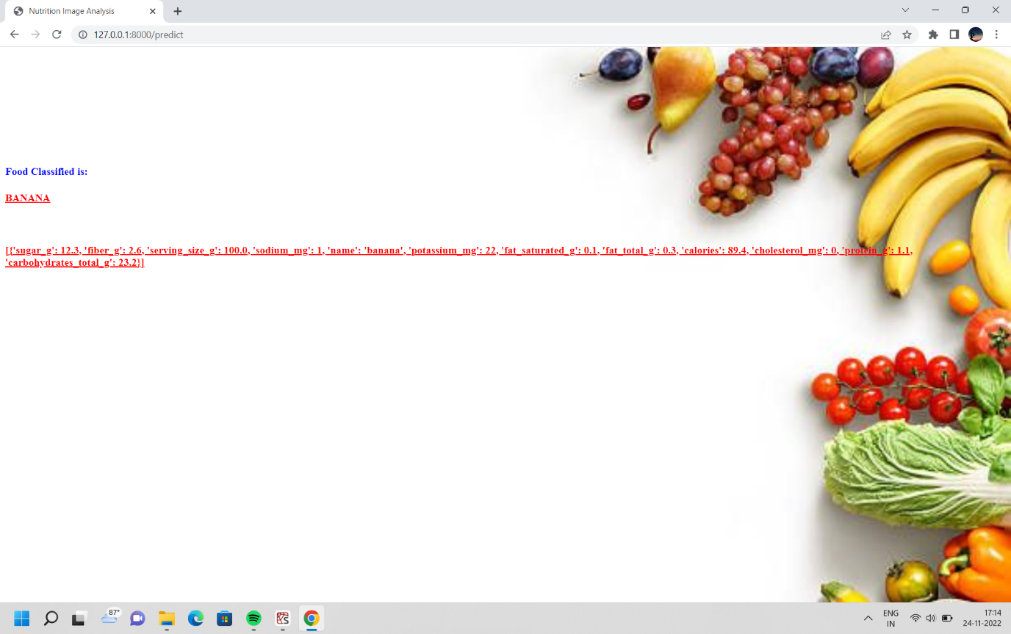ered nutrition analyzer for fitness enthusiast using ibm watson

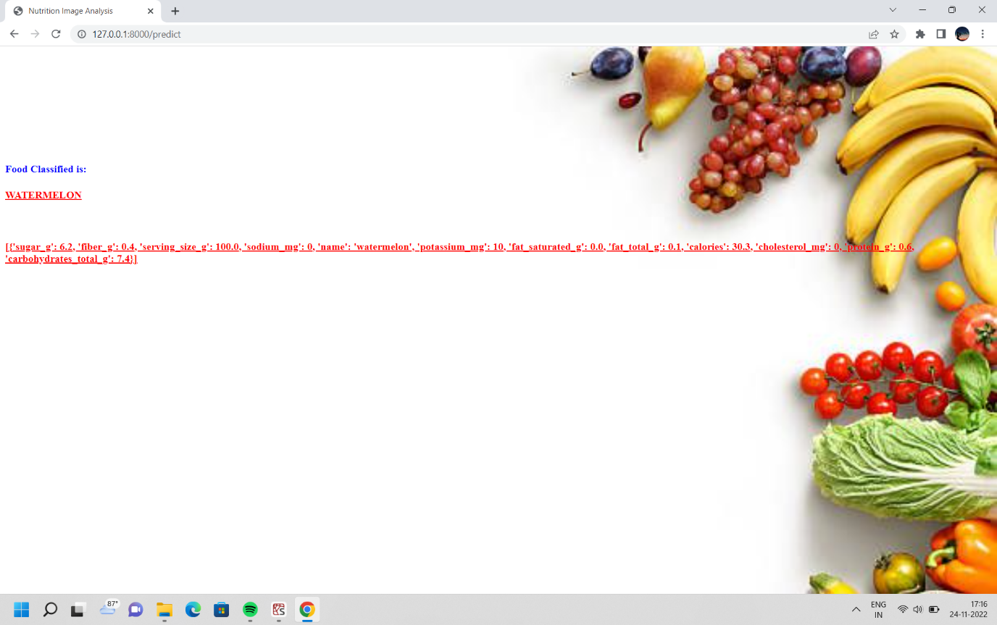

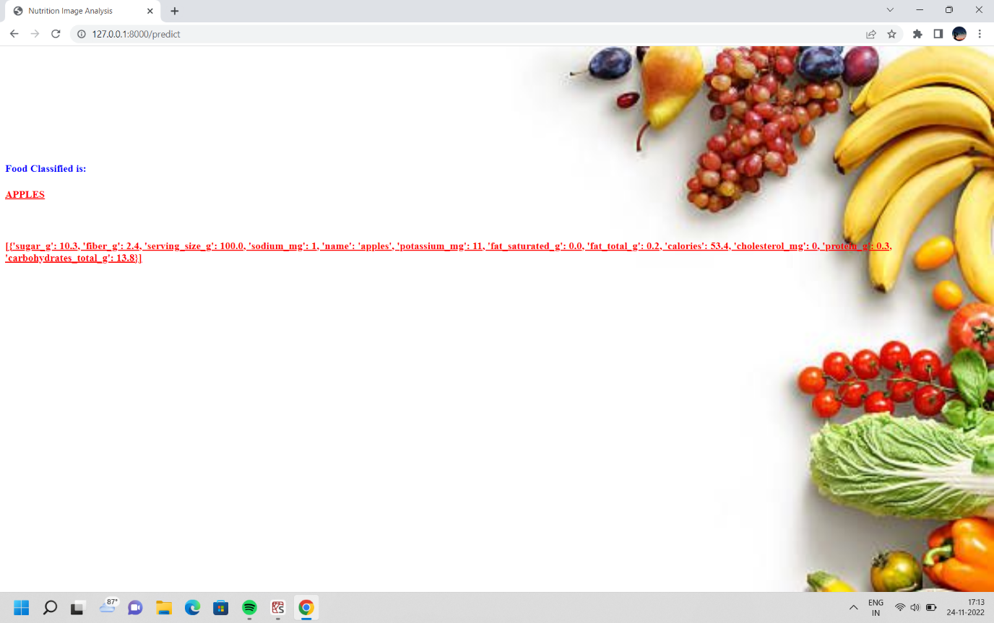

Fig: Output Page Ai-powered nutrition analyzer for fitness enthusiast using ibm watson

**CHAPTER 7**

**ADVANTAGES AND DISADVANTAGES**

**ADVANTAGES**

* 1. **Reduction in human errors**
  2. **Better decision making**
  3. **Increased productivity**
  4. **Improved customer experience**

**DISADVANTAGES**

1. **Lack of data security**
2. **Bias**
3. **Privacy concerns**
4. **Costly implementation**

**CHAPTER 8**

**APPLICATIONS**

1. Nutritional analysis is the process of determining the nutritional content of food. It is a vital part of analytical chemistry that provides information about the chemical composition, processing, quality control and contamination of food.
2. The main aim of the project is to building a model which is used for classifying the fruit depends on the different characteristics like colour, shape, texture etc.
3. The model analyses the image and detect the nutrition based on the fruits like (Sugar, Fibre, Protein, Calories, etc.).

**CHAPTER 9**

**CONCLUSION AND FUTURESCOPE**

**CONCLUSION**

On the basis of this review, it is worthwhile to consider the possibility of creating AI systems to coordinate both biomedical and clinical nutrients research with nutritional epidemiology. Perhaps the gut microbiota function may be an important mediator of this kind of advanced coordination. Therefore, research on the importance of the intestinal flora is of fundamental importance in the field of nutrients research. A significant challenge for the near future is the use of AI technology in the creation of gut microbiota biobanks for the purpose of scientific research . Despite the fact that AI technologies are dynamically developing, the problem in nutrients research is not currently obtaining more and more advanced algorithms, but the application of those that have already been developed and are standardly used in other fields of knowledge, and even in other areas of biomedicine. An important challenge for Nutrients 2021, 13, 322 13 of 16 nutrients research is also their integration with research on the use of medical robotics. Perhaps the development and application of AI in nutrients research requires modification of both mentality and professional competences, as is already postulated in relation to the food industry.

**FUTURESCOPE**

An important challenge for Nutrients 2021, 13, 322 13 of 16 nutrients research is also their integration with research on the use of medical robotics. Perhaps the development and application of AI in nutrients research requires modification of both mentality and professional competences, as is already postulated in relation to the food industry.

**CHAPTER 10**

**BIBILOGRAPHY**

1.McCarthy, J.; Minsky, M.; Rochester, N.; Shannon, C.E. A Proposal for the Dartmouth Summer Research Project on Artificial Intelligence. 1955. Available online: http://raysolomonoff.com/dartmouth/boxa/dart564props.pdf (accessed on 6 November 2020).

2. Nilsson, N.J. The Quest for Artificial Intelligence; Cambridge University Press: Cambrige, UK; New York, NY, USA, 2010.

3. Ting, D.S.W.; Pasquale, L.R.; Peng, L.; Campbell, J.P.; Lee, A.Y.; Raman, R.; Tan, G.S.W.; Schmetterer, L.; Keane, P.A.; Wong, T.Y. Artificial intelligence and deep learning in ophthalmology. Br. J. Ophthalmol. 2018, 103, 167–175. [CrossRef]

4. Yasaka, K.; Abe, O. Deep learning and artificial intelligence in radiology: Current applications and future directions. PLoS Med. 2018, 15, e1002707. [CrossRef] [PubMed]

5. Johnson, K.W.; Torres Soto, J.; Glicksberg, B.S.; Shameer, K.; Miotto, R.; Ali, M.; Ashley, E.; Dudley, J.T. Artificial intelligence in cardiology. J. Am. Coll. Cardiol. 2018, 71, 2668–2679. [CrossRef] [PubMed]

6. Hessler, G.; Baringhaus, K.-H. Artificial intelligence in drug design. Molecules 2018, 23, 2520. [CrossRef] [PubMed]

7. Heydarian, H.; Adam, M.T.P.; Burrows, T.; Collins, C.E.; Rollo, M.E. Assessing eating behaviour using upper limb mounted motion sensors: A systematic review. Nutrients 2019, 11, 1168. [CrossRef] [PubMed]

8. Demirci, F.; Akan, P.; Kume, T.; Sisman, A.R.; Erbayraktar, Z.; Sevinc, S. Artificial neural network approach in laboratory test reporting: Learning algorithms. Am. J. Clin. Pathol. 2016, 146, 227–237. [CrossRef]

9. Valletta, E.; Kuˇcera, L.; Prokeš, L.; Amato, F.; Pivetta, T.; Hampl, A.; Havel, J.; Va ˇnhara, P. Multivariate calibration approach for quantitative determination of cell-line cross contamination by intact cell mass spectrometry and artificial neural networks. PLoS ONE 2016, 11, e0147414. [CrossRef]

10. Agatonovic-Kustrin, S.; Beresford, R. Basic concepts of artificial neural network (ANN) modeling and its application in pharmaceutical research. J. Pharm. Biomed. Anal. 2000, 22, 717–727. [CrossRef]

**APPENDIX**

**A Source Code of Flask:**

from flask import Flask,render_template,request

# Flask-It is our framework which we are going to use to run/serve our application.

#request-for accessing file which was uploaded by the user on our application.

import os

import numpy as np #used for numerical analysis

from tensorflow.keras.models import load_model#to load our trained model

from tensorflow.keras.preprocessing import image

import requests

app = Flask(__name__,template_folder="templates") # initializing a flask app

# Loading the model

model=load_model('nutrition.h5')

print("Loaded model from disk")

@app.route('/')# route to display the home page

def home():

return render_template('home.html')#rendering the home page

@app.route('/image1')# routes to the index html

def image1():

return render_template("image.html")

@app.route('/predict',methods=['GET', 'POST'])# route to show the predictions in a web UI

def launch():

print('Hello')

if request.method=='POST':

print('Hi')

f= request.files["image"] #requesting the file

print("hi2")

basepath=os.path.dirname('__file__')#storing the file directory

filepath=os.path.join(basepath,"uploads",f.filename)#storing the file in uploads folder

f.save(filepath)#saving the file

img=image.load_img(filepath,target_size=(64,64)) #load and reshaping the image

x=image.img_to_array(img)#converting image to an array

x=np.expand_dims(x,axis=0)#changing the dimensions of the image

pred=np.argmax(model.predict(x), axis=1)

print("prediction",pred)#printing the prediction

index=['APPLES','BANANA','ORANGE','PINEAPPLE','WATERMELON']

result=str(index[pred[0]])

x=result

print(x)

result=nutrition(result)

print(result)

return render_template("0.html",showcase=(result),showcase1=(x))

def nutrition(index):

url = "https://calorieninjas.p.rapidapi.com/v1/nutrition"

querystring = {"query":index}

headers = {

'x-rapidapi-key': "5d797ab107mshe668f26bd044e64p1ffd34jsnf47bfa9a8ee4",

'x-rapidapi-host': "calorieninjas.p.rapidapi.com"

}

response = requests.request("GET", url, headers=headers, params=querystring)

print(response.text)

return response.json()['items']

if __name__ == "__main__":

# running the app

app.run(debug=False, port=8000)